1: Check Windows System Information
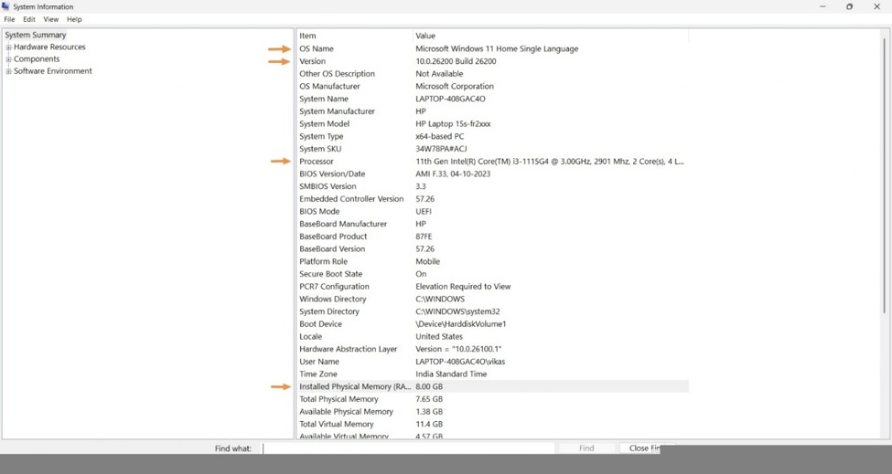

3 : Change Desktop Wallpaper and System Language
1. Change Desktop Wallpaper (Windows 10/11)
- Right-click on the desktop.
- Select Personalize.
- Click on Background.
- Choose a picture for the desktop wallpaper.
- The wallpaper will change automatically.
2. Change System Language to Hindi or Gujarati
- Open Settings.
- Click on Time & Language.
- Select Language & Region.
- Click on Add a language.
- Search for Hindi or Gujarati.
- Select the language and click Next.
- Click Install.
- Select the language under Windows display language.
- Sign out and sign in again if required.

5 : Windows 10 Installation – Steps
- Backup Data: Save important files before installation.
- Create Bootable USB: Use Rufus to make a Windows 10 bootable USB.
- Boot from USB: Restart the laptop and select the USB from Boot Menu.
- Start Setup: Select language, keyboard, and click Install Now.
- Select Edition: Choose the correct Windows 10 edition.
- Choose Installation: Select Custom Installation.
- Partition Disk: Select or create a partition for Windows. Keep important data safe.
- Install Windows: Select the partition and click Next.
- Complete Setup: Set region, Wi-Fi, account, and PIN.
- Privacy Settings: Turn off unnecessary location and data-sharing options.
- Update Windows: Go to Settings → Update & Security → Windows Update.
- Install Drivers: Install missing Wi-Fi, audio, graphics, and other drivers.
- Final Check: Restart and check that all hardware works properly.
Unclear/Missing Steps: The Boot Menu key differs by laptop brand, and partitioning should be done carefully to avoid data loss.

